Conversation with a work of art
Prof. Vasquez

Description
Your writing assignment for this quarter will be based on your encounter with an artwork. Keep in mind you don’t have to like the work of art you choose to have a conversation with. You may challenge it on any grounds you feel it is deficient in or otherwise. I have attached an example you can refer to for formatting tips and style.
You must include biographical information about the artist as well as some historical context related to the artwork itself, such as style, date of creation, materials, country where it was created and any other information you think is relevant.
BE SURE TO SPELLCHECK YOUR WORK!

Format
750-1000 words
Double spaced
Include cover sheet with the information shown below:
(Note: cover sheets information should be on a separate page from the actual content of your essay)

Your name
Title of your essay
Title of the artwork your are conversing with
Name of the artist
Class number and section
Professor Vasquez
Date
A photograph of the work

Julia Arroyo
Conversation with a Work of Art
The Penitent Saint Peter
El Greco
Art 107 Painting 1
Professor Vasquez
10/28/2016
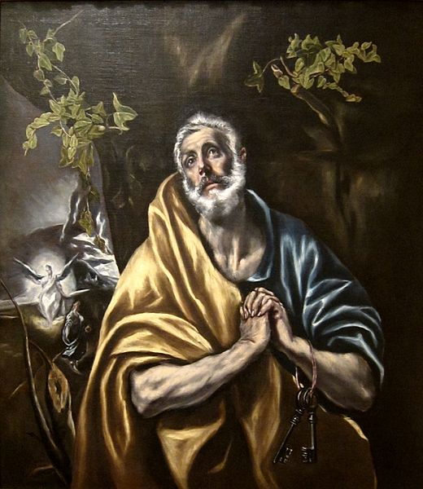

AUTHOR: [silence]
PAINTING: ...yes?
AUTHOR: I’m sorry, the emotion you capture has left me speechless.
PAINTING: Oh. I see. I seem to have that effect.
AUTHOR: Speechless in an amazing way. Judging by the small, iridescent figure in the left, are
you a religious painting? It looks like an angel.
PAINTING: Why, yes, yes I am.
AUTHOR: Who made you?
PAINTING: A man named Domenikos Theotokópoulos.
PAINTING and AUTHOR: […]
PAINTING: Most know him as El Greco.
AUTHOR: Oh! I’ve heard of him before!
PAINTING: Yes. He painted me between 1590 and 1595 with oil paint. I am one of at least six known versions of this scene. He was born in Crete, Republic of Venice, where he trained and became a master post-Byzantine artist. Eventually he moved to Spain with the success of his career. Yet, here I am now, in the San Diego Museum of Art. Watching countless people stand before me, holding the sadness of Saint Peter in their hearts. And perhaps relating to his repentance.
AUTHOR: Is that who this man is?
PAINTING: Obviously. Don’t you see his blue and yellow robes? Or his keys?
AUTHOR: I’m sorry, I’m not very knowledgeable about saints and their stories…
PAINTING: We get a lot of people like you these days. I forget what era I’m in sometimes. No matter, no matter, I will simply tell you the story.
PAINTING: It’s a story that comes from the gospel of Mathew. On the night Christ was going to be arrested, Peter was questioned and denied knowing or having any association with Christ three times. After the crucifixion, Peter goes off by himself, extremely upset, in penitence. He’s overcome with guilt, for he has forsaken his savior. For this story, he has become widely affiliated with the importance of repentance and confession. It is also a remarkable story of devotion that gives sinners the hope that they may be forgiven, for Peter is later forgiven by Christ and is even given the keys to heaven, and becomes the first Pope.
AUTHOR: The way he’s holding his hands so strongly. His tearful eyes…the guilt is almost palpable. It makes my heart feel heavy. Yet what an amazing inspiration for forgiveness. But who are the two figures in the background?
PAINTING: It’s rude to interrupt. As the story goes, Mary Magdalene discovers the empty tomb of Christ and is visited by an angel. The scene behind St. Peter is the moment Magdalene discovers that Christ has risen again. The angel tells Magdalene to run off and tell Peter. This crucial moment behind St. Peter foreshadows his ever-coming forgiveness.
PAINTING and AUTHOR: […]
PAINTING: I’m finished.
AUTHOR: Wow… Knowing this story makes you that much more intense and emotional.
AUTHOR: The story I understand now, is very important, but I feel the skill and artistry of El Greco makes it only more so.
PAINTING: He is quite talented, isn’t he?
AUTHOR: The way the objects in the foreground are so bright compared to everything else in the background. I’ve never seen anything like it before.
PAINTING: This is a technique known as chiaroscuro, where an artist pays close attention to light and shading. Or the art of tenebrism: using large areas of shadow and dark colors, usually with a shaft of light. It is also called dramatic illumination. El Greco uses large amounts of white to bask his objects in the foreground with an almost ethereal light. The church loved how this added importance and drama to religious depictions.
AUTHOR: Wow…El Greco’s scaling is very unique also. How can he scale these figures this way but still achieve the appearance of distance and perspective?
PAINTING: Well, to not make Mary Magdalene appear as a small person by his elbow, and rather a full-sized person in the distance, El Greco has added vivid depth, detail, and light to the foreground objects—St. Peter and the ivy leaves. With more distant objects, he used less detail and darker colors.
AUTHOR: Amazing! And did you say ivy leaves? Is it safe to say there’s symbology behind them?
PAINTING: Have you never taken an art history class in your life? Symbolically, the ivy has always been closely identified with death and immortality. Because it is forever green, it is a symbol of fidelity and eternal life. The ivy, which clings to its support, is also a symbol of attachment and undying affection.
AUTHOR: Your detail, your emotion, your colors. You simply blow me away. You truly are a beautiful work of art.
PAINTING: I know.

