For Immediate Release
Contact: Perry Vásquez
plvasque@gmail.com
(619) 244-9302

Dantesque music project to be released on Good Friday

San Diego, CA — On Good Friday, April 14, 2017, artist Perry Vásquez will release his Dante-inspired concept album, The Gates of Heck. The date was chosen to coincide with the chronology of Dante’s Inferno in which the poet journeys through the underworld for three days beginning on Good Friday.

The album release is the new form of a project that began in 2008 and has spanned collage, painting and live performance. Vásquez hopes the latest incarnation will spark discussion around topics of morality and social justice.

“I believe Dante remains relevant because he speaks to the human condition. Given the current political and social climate his ideas have gained even more significance,” said Vásquez.

One track, “Bourgeois in Hell,” tells the story of a wealthy entrepreneur who finds himself cast into the underworld after a life of luxury and prideful accomplishment. Vásquez uses his story to explore the concept of contrapasso, Dante’s idea that penalties in the afterlife reflect the nature of the moral crime.

“One of the principal problems Dante warns against is a loss of our senses of justice and morality. Everywhere we see signs of corruption and greed in our politics and within our social fabric. To be able to maintain a higher moral order in our society we must maintain our sense of justice.”

“Shades” narrates a contemporary migrant’s journey and frames it in the context of Homeric epics. “The trend to demonize migrants as sociopathic illegals is alarming. I wanted to balance those negative views by writing a piece that emphasizes the heroic nature of their experiences. If we can’t have compassion for those less fortunate among us, Dante would say we are lost as a society.”

The minimalist track “Inferno” seems to hint that the allegorical flames of Hell could easily become the real flames of environmental crisis. “Dante urges us to become custodians of our own fate. As global citizens we must confront head-on our many complex problems or face our own extinction. We have to find the political and moral will to preserve our environment rather than continue to exploit it for profit.”

Vásquez composed in a range of musical genres for the album including rock, avant-garde, spoken word and folk ballad. The album’s eclectic nature was partially in response to the eclectic mixture of Dante’s poetic styles.

The Gates of Heck project started as a collaged tribute to Auguste Rodin’s Gates of Hell, a monumental sculpture depicting characters from Dante’s Inferno. Vasquez’s version added a twist.

Instead of repeating Rodin’s cast of classical nudes, Vásquez exchanged them for a host of modern day superheroes: Spiderman, the Fantastic Four, Mary Marvel and Batman among others. The choice of characters reflects Vásquez’s reading habits as a young boy as well as his desire to grab the attention of a contemporary audience.

The collage became a silkscreen print, sold through online galleries. In 2012, Vásquez transferred the design to canvas and spent two years painting more than 120 figures sprawled across the architecture of the Gates.

It was during this period that he expanded the project into music.

After the painting was finished in 2014, Vásquez presented The Gates of Heck at downtown’s Canvas Gallery as live performance art, accompanied by immersive video projections from multimedia artist Aaron McFarland.

In 2016, the songs were recorded and readied for digital download. Reflecting on the relatively long gestation period, Vásquez notes that Rodin worked on The Gates of Hell for 37 years.

Vásquez is an established visual artist, activist and educator. His Keep on Crossin’ project – created in collaboration with Victor Payan, and also presented in a range of media – has been shown at the Museum of Contemporary Art San Diego, UC Riverside's Sweeney Art Gallery, and as part of Art San Diego’s Open Walls Project. In 2010 Vásquez established the Border Corps, a collective of Southern California-based performers, artists and musicians who experiment with new forms of performance art, interactive theater, art history, poetry, literature and video.

He teaches drawing and painting at Southwestern College and currently serves as the director for the Southwestern College Art Gallery.

The full track list follows:

- Gates
- Inferno
- Shades
- Bourgeois in Hell
- Phlegethon
- Satan
- Gates II
- No Exit

The Gates of Heck will be available for download from Bandcamp, iTunes, Spotify and other online music sites. A physical cd, signed and numbered, will also be available to buy from www.PerryVasquez.com/collect

# # #

************************
Perry Vásquez
(619) 244-9302
plvasque@gmail.com
www.perryvasquez.com
https://www.instagram.com/this_is_not_a_pope
http://www.facebook.com/perry.vasquez.520

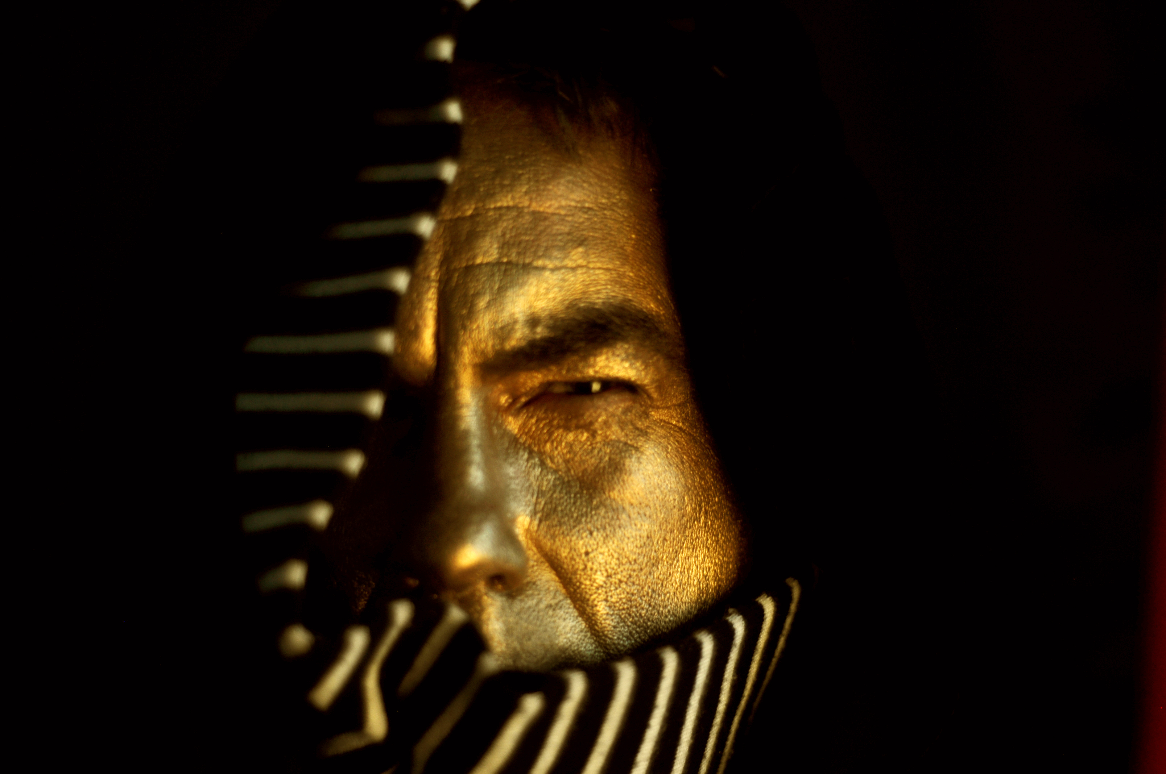
Perry Vasquez
Photo by gumisforlovers

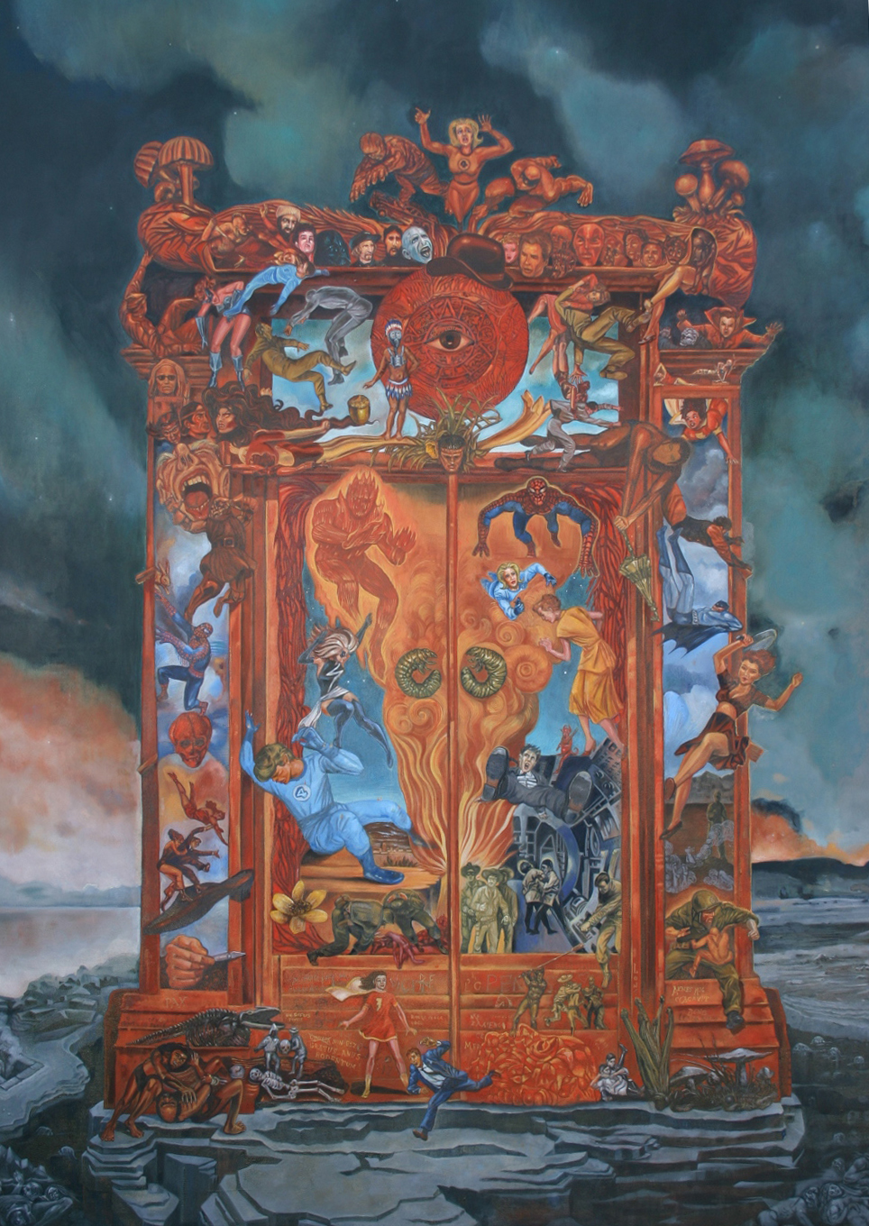
Perry Vasquez
The Gates of Heck
Oil on Canvas 2014

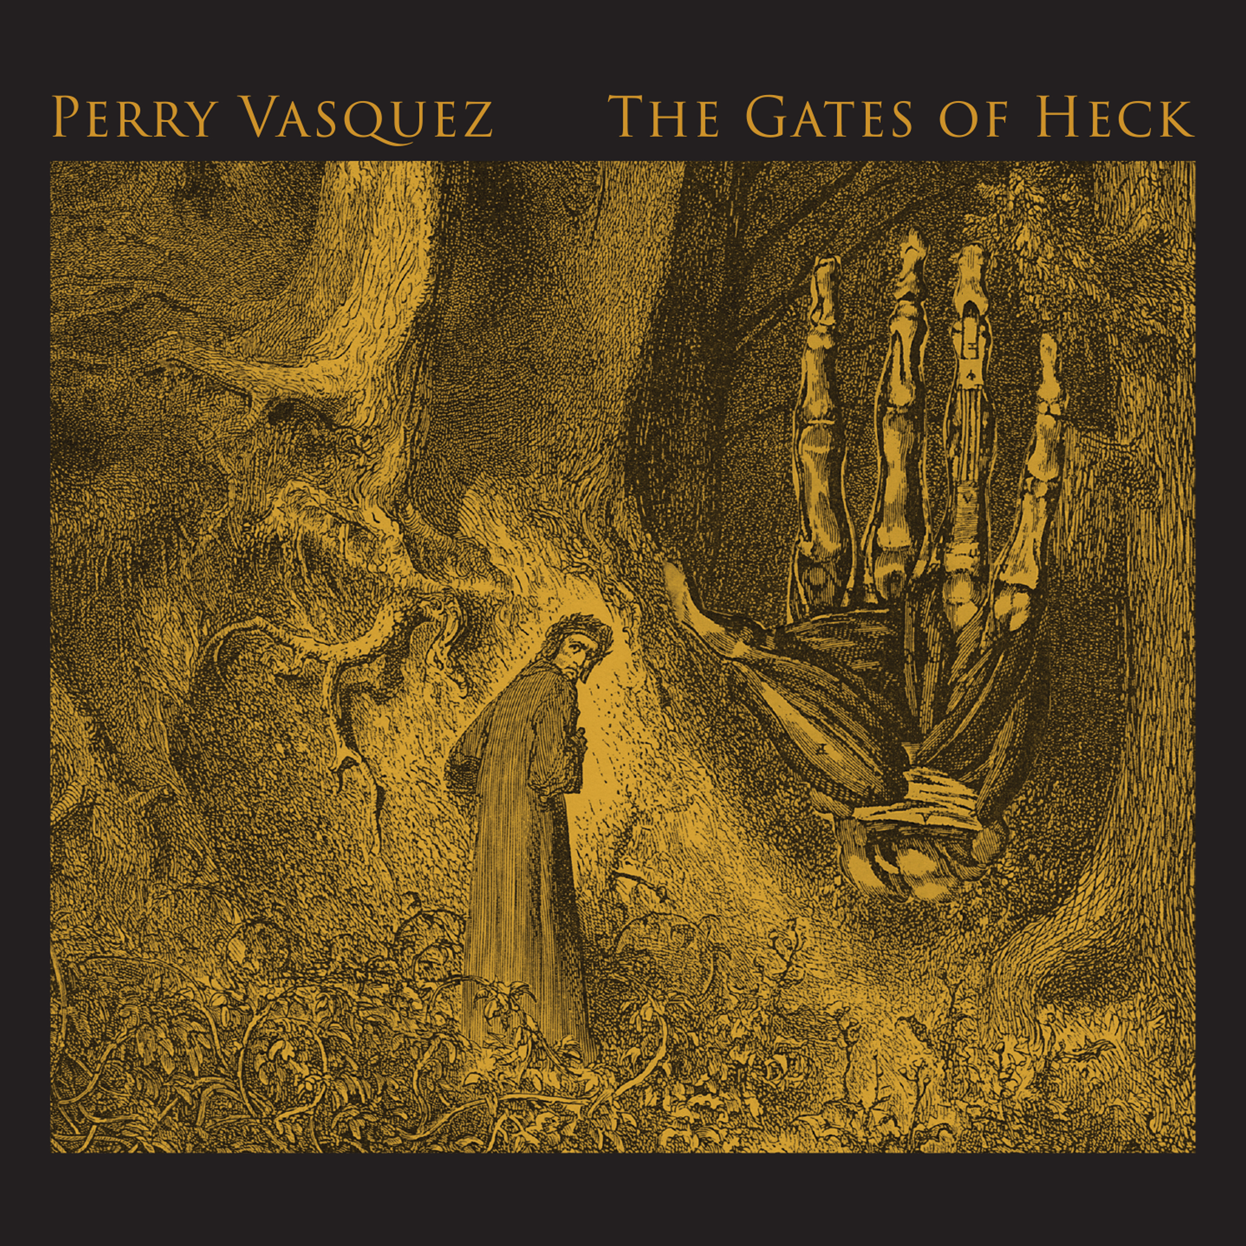

Perry Vasquez
The Gates of Heck
Album art

